Technical Implementation Guide: Fraudulent Account Detection System
Objective: Automatically detect and delete fake accounts impersonating prominent individuals using AI/ML, real-time monitoring, and user feedback.

1. System Overview
The solution involves:
- Profile Analysis (Name, Photo, Mutual Friends)
- Real-Time Chat Monitoring (Keyword Detection)
- User Warnings & Feedback
- Automated Account Suspension & Human Moderation

2. Technical Components & Tools
A. Profile Analysis
a. Detect Same Name as Prominent Person
- Technology: Natural Language Processing (NLP)
- Tools:
  - Python Libraries: spaCy, NLTK, or FuzzyWuzzy for fuzzy name matching.
  - Database: Store names of prominent people in a PostgreSQL/MySQL database.
- Implementation:
from fuzzywuzzy import fuzz

def is_prominent_name(user_name, prominent_names):
for name in prominent_names:
if fuzz.ratio(user_name.lower(), name.lower()) > 85: # Threshold
return True
return False
b. Check Profile Photo Against Known Images
- Technology: AI-Powered Facial Recognition
- Tools:
  - Frameworks: TensorFlow, PyTorch, or OpenCV.
  - Pre-trained Models: FaceNet, DeepFace, or AWS Rekognition.
- Implementation:
import deepface

def compare_faces(user_photo, prominent_photos_db):
for photo in prominent_photos_db:
result = deepface.verify(user_photo, photo, model_name="Facenet")
if result["verified"]:
return True
return False
c. Cross-Verify Mutual Friends
- Technology: Graph Analysis
- Tools:
  - Graph Databases: Neo4j or Amazon Neptune.
  - APIs: Use social media platform’s API (e.g., Facebook Graph API) to fetch mutual friends.
- Implementation:
def check_mutual_friends(user_account, prominent_person_account):
user_friends = get_friends(user_account) # Platform API call
prominent_friends = get_friends(prominent_person_account)
overlap = len(set(user_friends) & set(prominent_friends))
if overlap < 5: # Threshold (e.g., <5 mutual friends)
return "Suspicious"

B. Real-Time Chat Monitoring
a. Keyword Detection
- Technology: NLP for Text Classification
- Tools:
  - Libraries: Hugging Face Transformers, spaCy
  - Keywords: Predefined list (e.g., "send money", "trading").
- Implementation:
fraud_keywords = ["send money", "trading", "help me with cash"]

def detect_fraud_keywords(chat_text):
for keyword in fraud_keywords:
if keyword in chat_text.lower():
return True
return False
b. Pop-Up Warning
- Technology: Frontend Integration
- Tools:
  - Frontend Frameworks: React, Angular, or Vue.js
  - APIs: REST/GraphQL to trigger warnings in real-time.
- Implementation:
// React example
function showFraudWarning() {
alert("Beware of Fraud! This account may be impersonating someone.");
}

C. Automated Review & Account Suspension
a. Flagging & Automated Review
- Technology: Rule-Based Systems + Machine Learning
- Tools:
  - ML Frameworks: Scikit-learn, XGBoost
  - Automation: Celery for task queues
- Implementation:
from sklearn.ensemble import RandomForestClassifier

# Train ML model to prioritize high-risk accounts
model = RandomForestClassifier()
model.fit(training_data, labels)
b. Account Deletion
- Technology: Backend Automation
- Tools:
  - Server-Side Frameworks: Django, Flask, or FastAPI
  - Database: PostgreSQL or MongoDB
- Implementation:
# Django example
def delete_fraud_account(user_id):
user = User.objects.get(id=user_id)
user.delete()

D. Human Moderation & Feedback Loop
a. Escalation to Moderators
- Tools:
  - Dashboard: Tableau, Power BI, or custom dashboards
  - APIs: Slack/Microsoft Teams integration for alerts
b. User Feedback
- Tools:
  - Database: Log user responses in Firebase or AWS DynamoDB
  - Analytics: Retrain ML models using feedback data

3. Integration & Deployment
Component | Tools
Backend | Python (Django/Flask), Node.js, AWS Lambda
AI/ML | TensorFlow, PyTorch, Hugging Face, OpenCV
Database | PostgreSQL, MongoDB, Neo4j
Real-Time | Apache Kafka, RabbitMQ, AWS Kinesis
Frontend | React, Angular, Vue.js
Cloud | AWS, Google Cloud, Azure
APIs | REST/GraphQL, Facebook Graph API, Twitter API
Monitoring | Prometheus, Grafana, ELK Stack

4. Implementation Steps
- Setup Infrastructure:
  - Deploy cloud servers (AWS EC2/Azure VM)
  - Configure databases (PostgreSQL for profiles, Neo4j for social graphs)
- Build AI Models:
  - Train facial recognition models using TensorFlow/PyTorch
  - Fine-tune NLP models for keyword detection
- Develop APIs:
  - Create REST APIs for profile checks, chat monitoring, and account deletion
- Integrate Real-Time Alerts:
  - Use WebSocket or Kafka for real-time chat monitoring
- Deploy User Interface:
  - Build a dashboard for moderators (React + Django)
- Testing & Validation:
  - Use tools like Selenium (UI testing) and PyTest (backend testing)

5. Challenges & Mitigations
- False Positives: Use user feedback to refine ML models.
- Scalability: Use Kubernetes/Docker for containerization.
- Privacy: Ensure GDPR/CCPA compliance with anonymized data.

6. Conclusion
This system combines AI/ML, real-time monitoring, and user feedback to detect and delete fraudulent accounts. Tools like TensorFlow, React, AWS, and Neo4j form the backbone of the solution. Regular updates and retraining of models will ensure long-term effectiveness.

Flow Chart:
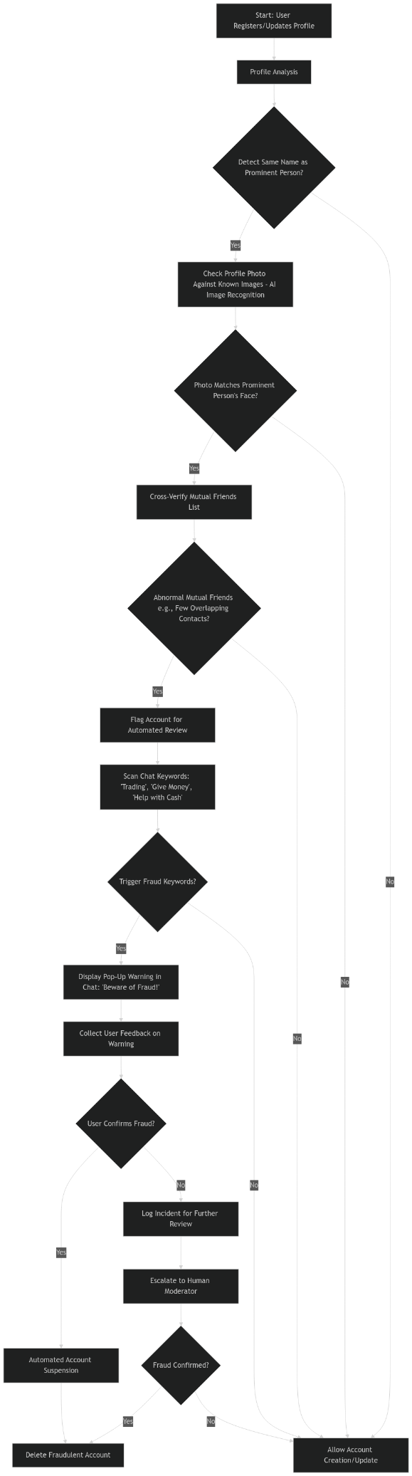
Mock up: Initial application demo
1.Extract the given zip file
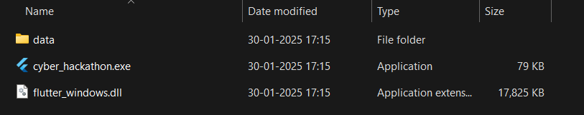
2.Run the .exe file
